EXPERIMENT NO. 08
DESIGN AND SIMULATION OF NOR-BASED ROM MEMORY
―――――――――――――――――――――――――――――――――――――――――――――――――――――――
AIM
To design and simulate a 4x4 NOR-based Read-Only Memory (ROM) array using LT Spice.
SOFTWARE USED
LT Spice
CIRCUIT DIAGRAM
Architecture and simulation schematics of the 4x4 NOR ROM array:
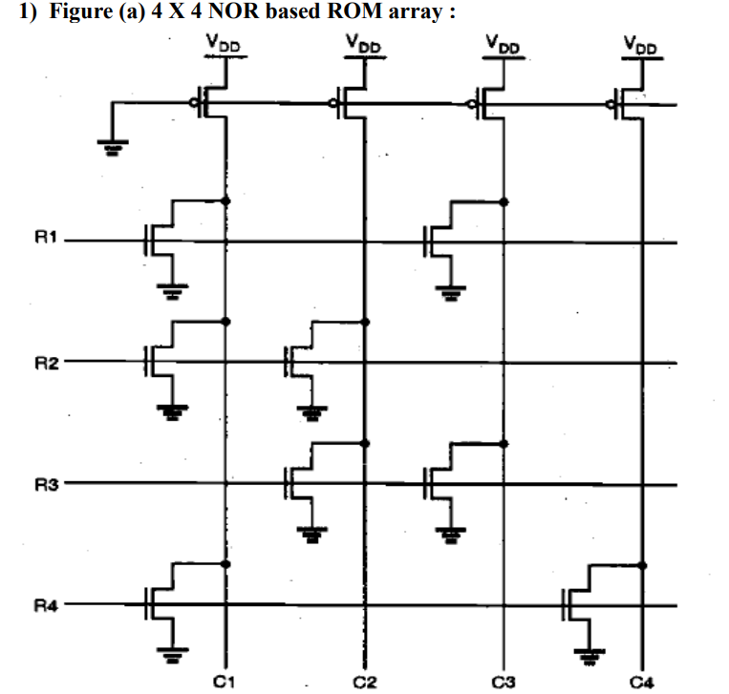
Figure 8.1: 4x4 NOR-Based ROM Array Architecture
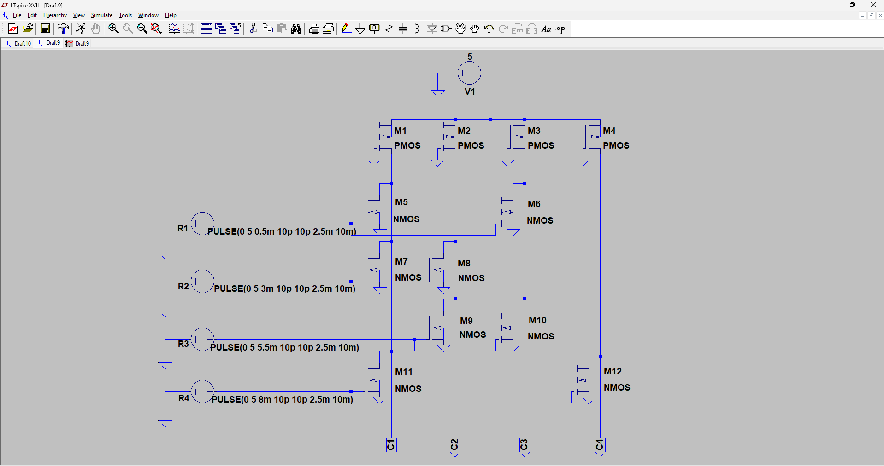
Figure 8.2: LT Spice Schematic of 4x4 NOR-Based ROM Array
SMALL THEORY
A Read-Only Memory (ROM) array is a non-volatile memory circuit that provides pre-programmed output data on column bit lines (C1 - C4) corresponding to each selected row word line address (R1 - R4). Storing binary data is achieved by the physical presence or absence of a pull-down transistor at each row-column cross-point.
- Pseudo-nMOS Architecture: Each column bit line comprises a pseudo-nMOS NOR structure with a PMOS load transistor connected to VDD whose gate is permanently tied to ground (0V).
- Word Line Selection: Only one word line (row) is activated at a time by raising its voltage to VDD (active HIGH). All unselected word lines remain at 0V.
- Logic '0' Representation: Presence of an active NMOS transistor at the intersection pulls the column bit line down to ground (Logic 0).
- Logic '1' Representation: Absence of an NMOS transistor at the cross-point leaves the column bit line pulled up to VDD by the PMOS load (Logic 1).
Truth Table for 4x4 NOR ROM Array:
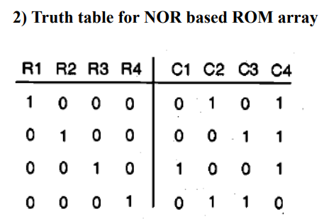
Figure 8.3: Address Decoding and Stored Data Truth Table
OUTPUT GRAPH
Transient read simulation waveforms obtained from LT Spice:
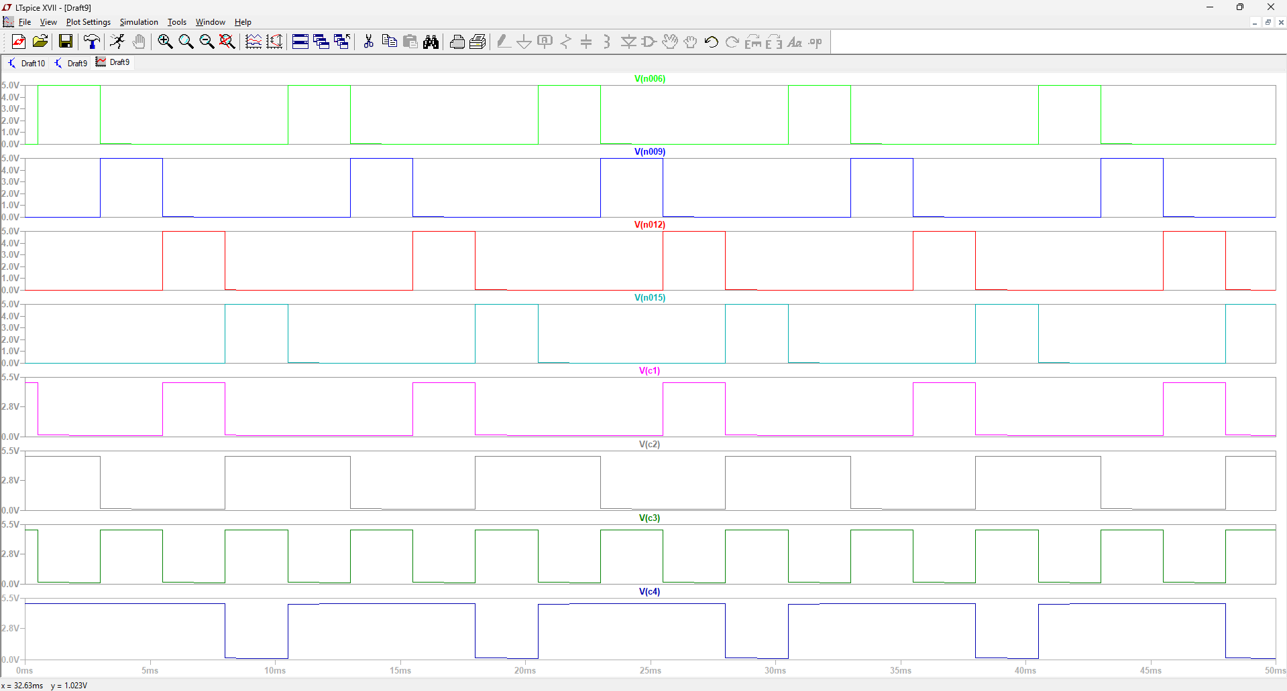
Figure 8.4: LT Spice Simulation Waveforms for Row Pulses and Output Bit Lines (C1 - C4)

